**Finance Overview**

A continued strong financial control of the operation is fundamental to deliver the vision for EVC.

Income has traditionally been received from sponsor’s and donors. This plan targets the growth of existing and new income streams from £237K in 2024 to £328k 2028 over the 5-year period.

This will be achieved by increasing the number of new child sponsorships by 40 /year over the 5-year period. Inviting child sponsorship donators to increase their donations from £300/year to £360/year from January 2026. Increasing the number of church appeals from 30 to 35 in 2027 and 2028.

In addition, maintaining funding donations from existing charitable trusts and growing this base but also generating new revenue streams from legacies / local business /website merchandise income and income from local Ugandan business and a major donor programme.

The charity continues to operate in large part by volunteers and is supported by an efficient staff team operating in Uganda. Therefore, the operating cost base is substantially lower than 10% of income.

The work of the charity has expanded since its inception to include project business planning and construction at the St Matia Mulumba school in Uganda. This has been enabled by substantial fund raising from high value donors and targeted fund raising. The 5-year plan builds on those successes by planning to complete the build of a nursery as well as a new kitchen and office accommodation and compound.

The shape of the income and expenditure over the 5-year period is outlined below with reference in more detail of how the income and costs are arrived at and the financial challenges faced by EVC to achieve this plan.

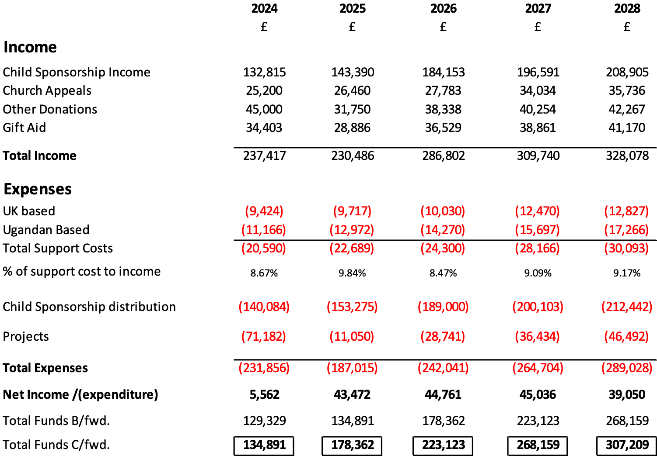

**Income**

Child Sponsorship – Included in the plan there is growth of 40 new sponsors spread over each year that also takes account of an expected 1% attrition rate per year over the 5-year period. This moves total net sponsor growth from a base of 417 at the 1st January to 591 in 2028. The current rate of sponsorship per child is £300 per annum which is planned to increase from the 1st January 2026 to £360 per annum. This is reflected in the significant increase Child Sponsorship income from 2025 to 2026 (£143k to £184K) a 26.6% increase. This significant increase seeks to close the current gap between in Child Sponsorship donations made and the rising actual costs in Uganda of school fees. It should be noted that the Child Sponsorship revenue is wholly distributed to Uganda and any shortfall is currently made up from other sources of income such as gift aid.

Church Appeals – This has been a particular successful source of income for EVC realising about £800/appeal and the 5-year plan builds on this success by including 30 appeals per year made at different locations in the UK rising to 35 per year in 2027 and 2028. This has been reflected in the shape of the revenue streams from this area of income increasing again significantly from 2026 to 2027 (£27.7k to £34K) which represents a 22.7% increase.

Other Donations – EVC has benefited from good flows of other donations from Marathons and Sponsored events as well as targeted short-term fundraising. There has also been success with Charitable trust donations such as SPICMA/SCORE/WILMSLOW and WELLS. A significant donation from a major donor in 2023 of £50,000 was made to support the Nursery Building at St Matia Mulumba (MM)school of which £20k was received in 2023 and tranches totaling £30k will be received in 2024. This major donation with the associated gift aid of £12.5k will enable the completion of the nursery building in 2024 early 2025.

It is planned that EVC will build on this success with maintaining levels of revenue from these existing streams as well as building a 5% year on year inflationary increase over the 5-year period.

Also included in the plan are new income streams from Legacies/Local Business/Website and Uganda businesses plus a major donor programme in support of the development of St MM school. It is also recognised that these increased new income streams will help to reduce risks associated with relying on existing income streams which may not always be available. The plan accepts it will take time for these new income streams to have traction and to start to contribute to EVC’s plan and vision.

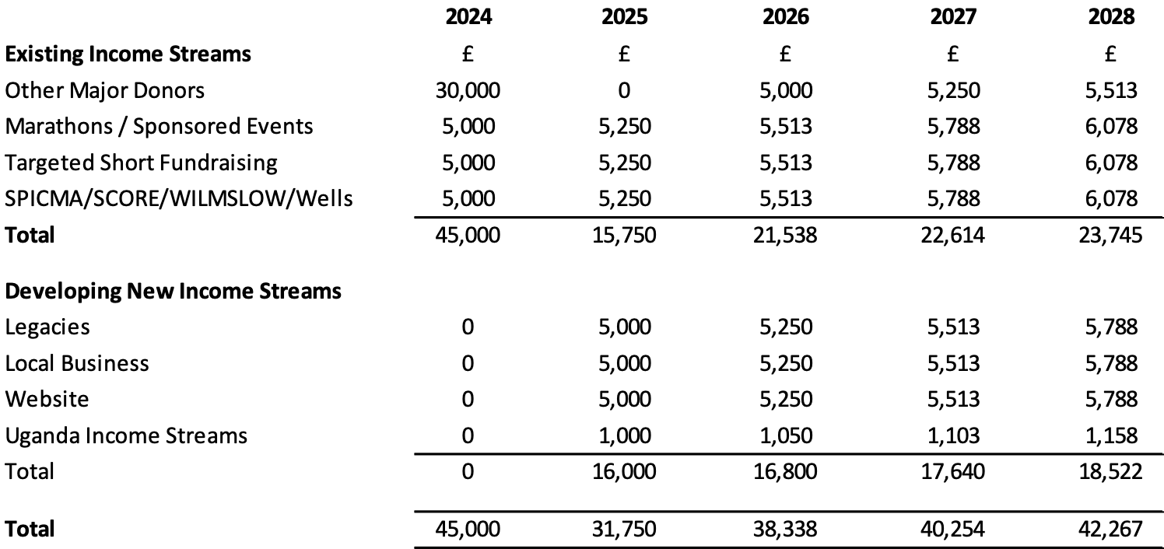

Plans will be put in place this year to ensure that EVC starts to realise income from these new sources in 2025 at £16k and then builds on this in 2026/2027/2028. There are challenges in reaching these targets however it is considered essential to open new channels of revenue for EVC to allow it the flexibility to achieve its vision.

Gift Aid – This flexible income is substantially achieved by declarations made by donators of Child Sponsorship. As the numbers of donators increases so will the amount of gift aid. The plan includes income based on 75% of declarations being made of the maximum 25% tax recovered from HMRC as it is recognized that each donator has different personal circumstances. The plan shows a significant increase in gift aid from 2025 to 2026 (£28.8k to £36.5K) which represents a 26.6% increase that correlates directly with the increase to of Child Sponsorship income arising because of the planned fee increase from £300 to £360 mentioned above.

**Expenditure**

UK Based Expenditure – This is analysed below and is in line with previous expenditure categories experienced by EVC to support the activity to communicate with our Donors and to raise income through appeals and increasing EVC’s Child Sponsorship numbers. The ambition to raise additional revenues through appeals by increasing the visited locations in a year from 30 to 35 in 2027 and 2028 is reflected in increased Trustee expenses from £4.7k in 2026 to £6.5k in 2027.All other expenditure categories include a 5% inflation year on year increase over the 5-year period.

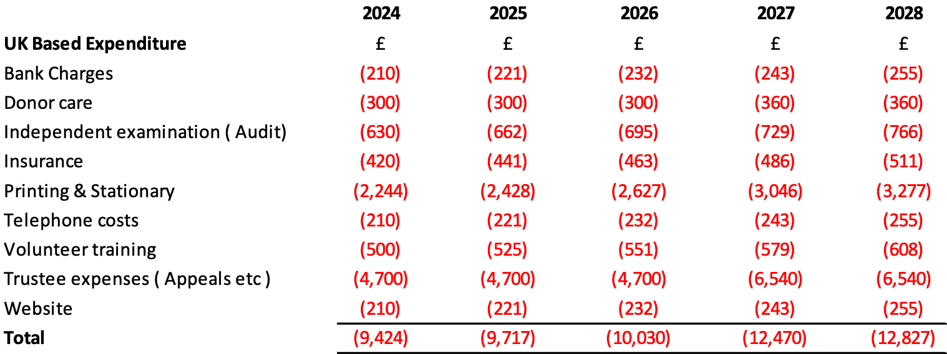

Ugandan Based Support Costs – These costs represent 3 staff based in Uganda whose roles are Head of Operations, Project Manager and Assistant Administrator. They provide an invaluable role in the smooth operation of EVC in its support to vulnerable children and the project development of the school. The continued development and growth of EVC’s support to St MM has necessitated the planned recruitment of a new Finance Assistant in June 2024.

It is considered that with this additional resource these 4 staff will continue to supply that invaluable support in Uganda on behalf of EVC. The costs also include provision for salary scale increments over the 5-year period as well as an inflationary provision for Ugandan each year.

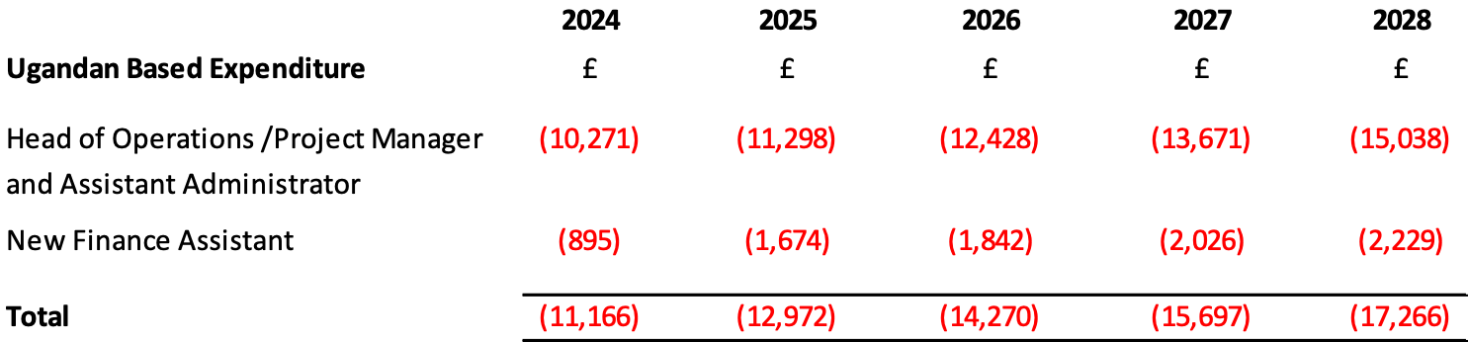

It should be noted that total UK based and Ugandan based support costs in generating the Revenue of EVC is less than 10% across the 5-year period.

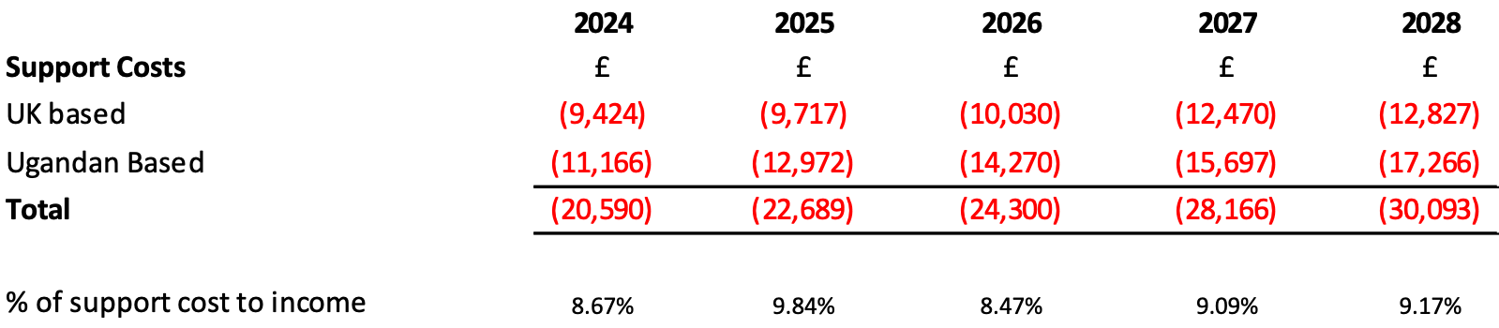

Child Sponsorship Distribution – as outlined above the Child Sponsorship donations received are transferred to Uganda on bi monthly basis with 6 transfers per year. This won’t exactly mirror the donations received in the year as there will be timing differences in the transfers and the distributions may include top ups to fund the gaps in current fees paid compared to the actual costs of the school fees. Again, as previously mentioned an invitation to EVC donors to increase donations from £300 to £360 will be made in January 2026 and the potential increase in income from that is reflected in Child Sponsorship Distributions moving from £153.2k in 2025 to £189k in 2026 a 25% increase.

Projects – Plans for building and development work are included in the 5-year plan as outlined in the table below

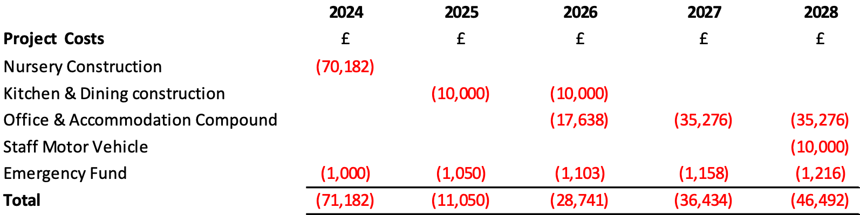

Nursery Construction is for building work in St MM and related costs. The work has already started in 2024 and is expected to be finished early 2025. This construction is substantially being funded by a major donation of £50k of which £20k was received in 2023 and the remaining £30k receivable in tranches in 2024. In addition, the related gift aid associated with this donation of £12.5k is

ringfenced to fund this project.

The Kitchen & Dining construction has only been part planned to complete in 2025 and 2026 by completing the smaller area of the Kitchen first and laying out a platform for the main dining space. It is estimated that this will cost £20k over the 2-year period. Completion of the dining room estimated at an additional £63K (Total of £20k + £63K = £83K) will only be undertaken when additional funding is secured to make that possible.

The Office and accommodation compound is a significant cost for EVC to support at £88k and has been deferred to 2026/2027 and 2028 to allow time to start generating the new revenue streams from other new donors.

The staff motor vehicle although again is essential can only be purchased when there is a secure compound to keep it. As the office & accommodation secure compound building works has been deferred to 2026/2027/2028 so has the purchase of the vehicle.

An emergency fund at £1000/year increased by 5% year on year for inflation has been included as contingency in the event of any unforeseen damage that may occur during the project construction work over the 5 years.

**Reserves**

The reserves of £134k at the end of 2024 have arisen due to a brought forward reserves £129.3k from 2023 plus the excess in Income to expenditure in the year 2024 at £5.5K.

Some judgements have been made to arrive at a breakdown of how the reserves are projected over the 5 years.

The unrestricted funds show an increasing build up year on year driven by current funding streams maintained and growth in gift aid arising due to increased numbers of sponsors (40 per year) and increased Child Sponsorship fees from January 2026. In addition to this new funding revenue streams from new donors as well as increased revenues from the additional numbers of appeals planned. All these increased revenues while at the same time support costs are maintained and growing at a much slower rate to the increased revenues planned. There are challenges and a level of uncertainty with generating this planned income growth and therefore some of the projects like the dining room build have been delayed as well as the Office accommodation and compound until targeted funding starts to materialise.

Designated funds are included as a contingency to support operating costs and increase year on year in line with 5% inflation with a base point in 2024 at £20k

Restricted funds substantially include estimates of Child Sponsorship funding that needs to be transferred that have arisen in the current year but have not been transferred by the end of the year as well as any top ups estimated to close the gap between Child Sponsorship fees paid and the actual cost of the school fees for the children.

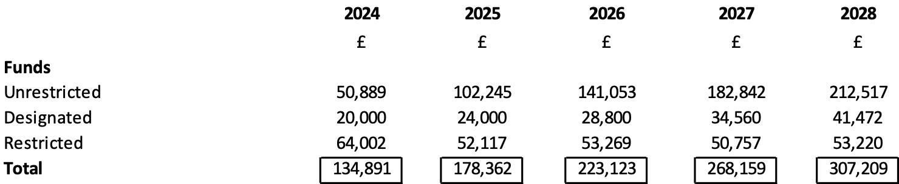

**Financial Risks**

The following risks /challenges have been identified with mitigating actions.

